Question 1:output your personal information

Program code

/*

function: output my personal information

*/

#include <iostream> // 包含头文件isotream

using namespace std; //使用命名空间std

int main()

{

cout<<"41431012 dutianbo "<<endl;

cout<<"male age:19 "<<endl;

cout<<"major:material class:material 1401"<<endl;

system("pause");

}

**Program analysis**:

This program has a main function. In this main function, there is only 3 cout statement, which is to output 3 simple strings in the standard monitor.

Program result

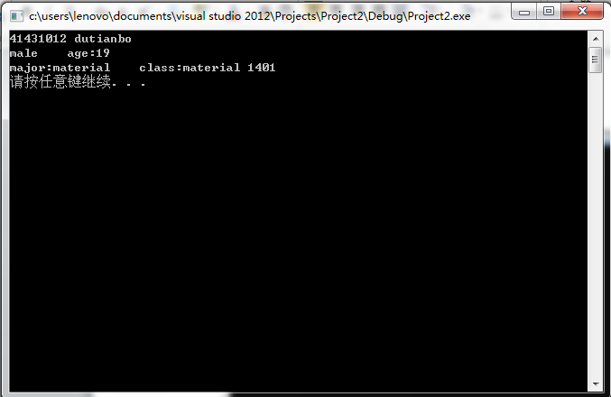

**Question 1**:

Output a **Isosceles triangle.**

**Program code**:

/***********************************

function: output a Isosceles triangle.

***********************************/

#include <iostream>

using namespace std;

void main()

{

cout<<" * "<<endl;

cout<<" * * "<<endl;

cout<<" * * * "<<endl;

cout<<" * * * * "<<endl;

cout<<"* * * * *"<<endl;

system("pause");

}

**Program analysis**:

This program has a main function. In this main function, there is only 5 cout statements.

In different lines, the statements outputs several ‘ * ’ to make the whole the output like a Isosceles triangle

**Program Result:**

